2.7 Parts b) and c)

Segment 1:

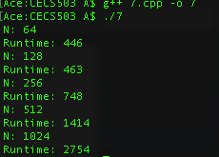

Analysis: Runtime shown in nanoseconds. The rate of growth for runtime should be linear, increasing by an approximate rate of 2. The runtimes gathered appear to do that, which confirms the big oh notation.

Segment 2:

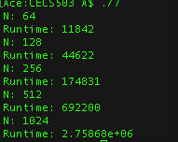

Analysis: Runtime shown in nanoseconds. The rate of growth for runtime should be quadratic, increasing by an approximate rate of 2^2(4). The runtimes gathered appear to do that, which confirms the big oh notation.

Segment 3:

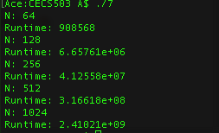

Analysis: Runtime shown in nanoseconds. The rate of growth for runtime should be cubic, increasing by an approximate rate of 2^3(8). The runtimes gathered appear to do that, which confirms the big oh notation.

Segment 4:

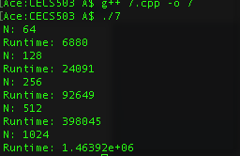

Analysis: Runtime shown in nanoseconds. The rate of growth for runtime should be quadratic, increasing by an approximate rate of 2^2(4). The runtimes gathered appear to do that, which confirms the big oh notation.

Segment 5:

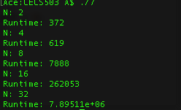

Analysis: Runtime shown in nanoseconds. The rate of growth for runtime should be quantic, increasing by an approximate rate of 2^5(32). The runtimes gathered don’t initially provide feedback confirming the suspected big oh notation, but start to demonstrate expected behavior as N grows larger. Big oh notation can be confirmed.

Segment 6:

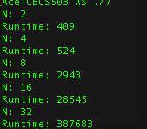

Analysis:

Analysis: Runtime shown in nanoseconds. The rate of growth for runtime should be quartic, increasing by an approximate rate of 2^4(16). The runtimes gathered don’t initially provide feedback confirming the suspected big oh notation, but start to demonstrate expected behavior as N grows larger. Big oh notation can be confirmed.